# EX2 Cifar10 Project Report

#### Asaf liberman 313230187

#### Nirel Yehoyada 205386675

#### Niv Zatelman 314764812

## Part 1: Cifar10 – Image Calcification

### Neural Network architecture num. 1:

1. Model architecture:

|  |  |  |  |  |  |  |  |
| --- | --- | --- | --- | --- | --- | --- | --- |
| Layer # | Type | Amount | Shape | Padding | Activation | Pooling | Dropout |
| 1 | Conv | 32 | (3,3) | True | Relu | - | - |
| 2 | Conv | 32 | (3,3) | - | Relu | Max(2,2) | 0.5 |
| 3 | Conv | 64 | (3,3) | True | Relu | - | - |
| 4 | Conv | 64 | (3,3) | - | Relu | Max(4,4) | 0.5 |
| 5 | Dense | 512 | - | - | Relu | - | 0.5 |
| 6 | Dense | 5 | - | - | Softmax | - | - |

1. Learning rate 0.00015
2. Decay 0.000001
3. Optimization algorithm: rmsprop
4. Loss function: categorical_crossentropy
5. Batch size: 256
6. Amount of epochs: 358
7. 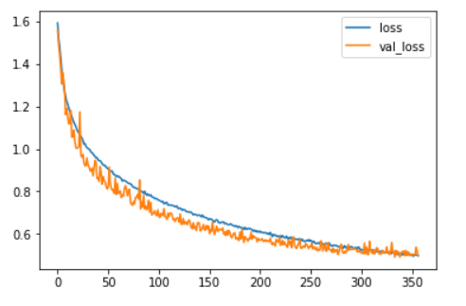A plot of training loss and validation loss:

### Neural Network architecture num. 2:

1. Model architecture:

|  |  |  |  |  |  |  |  |
| --- | --- | --- | --- | --- | --- | --- | --- |
| Layer # | Type | Amount | Shape | Padding | Activation | Pooling | Dropout |
| 1 | Conv | 32 | (3,3) | True | Relu | - | - |
| 2 | Conv | 16 | (2,2) | - | Relu | Max(1,1) | 0.5 |
| 3 | Conv | 8 | (3,3) | True | Sigmoid | - | - |
| 4 | Conv | 32 | (3,3) | True | Relu | - | - |
| 5 | Conv | 64 | (4,4) | - | Relu | Max(2,2) | 0.5 |
| 6 | Dense | 512 | - | - | Relu | - | 0.5 |
| 7 | Dense | 5 | - | - | Softmax | - | - |

1. Learning rate 0.0015
2. Optimization algorithm: adam
3. Loss function: categorical_crossentropy
4. Batch size: 350
5. Amount of epochs: 35
6. A plot of training loss and validation loss:

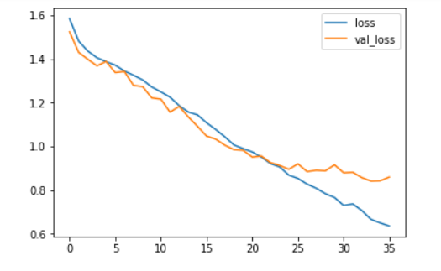

### Neural Network architecture num. 3:

1. Model architecture:

|  |  |  |  |  |  |  |  |
| --- | --- | --- | --- | --- | --- | --- | --- |
| Layer # | Type | Amount | Shape | Padding | Activation | Pooling | Dropout |
| 1 | Conv | 32 | (3,3) | True | Relu | - | - |
| 2 | Conv | 64 | (3,3) | - | Relu | Avg(2,2) | 0.25 |
| 3 | Conv | 128 | (3,3) | True | Relu | Avg(2,2) | - |
| 4 | Conv | 128 | (3,3) | True | Relu | Avg(2,2) | 0.25 |
| 5 | Dense | 1024 | - | - | Relu | - | 0.5 |
| 6 | Dense | 5 | - | - | Softmax | - | - |

1. Learning rate 0.0001
2. Optimization algorithm: rmsprop
3. Loss function: categorical_crossentropy
4. Batch size: 128
5. Amount of epochs: 100
6. 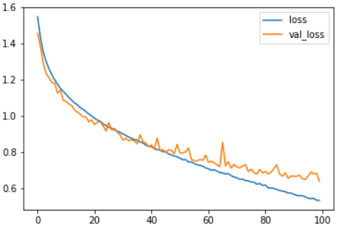A plot of training loss and validation loss:

## Part 2: Cifar10 – Transfer Learning (Is Flower)

1. Base Model architecture: The First Model that was presented was our base model.  
   New layers:

|  |  |  |  |  |  |  |  |
| --- | --- | --- | --- | --- | --- | --- | --- |
| Layer # | Type | Amount | Shape | Padding | Activation | Pooling | Dropout |
| 5 | Dense | 512 | - | - | Relu | - | 0.5 |
| 6 | Dense | 1 | - | - | sigmoid | - | - |

We only trained the two new layers in order to obtain the learning that has already been made on the Convolutional Neural Network that we are basing on.

1. Learning rate 0.0001
2. Optimization algorithm: rmsprop
3. Loss function: binary_crossentropy
4. Learning Data: 1500 Flowers, 1500 Not Flowers
5. Batch size: 4
6. Amount of epochs: 220
7. A plot of training loss and validation loss:

